### Room Finder Nepal

Roomsfindernepal is a web-based application. Rooms Finder Nepal is located at: Manamaiju, Kathmandu, Nepal 46000. According to alexa, roomsfindernepal.com has a global rank of #6991232 and it has some SEO issue. This site allows people to search for the property people need in their web. (Room Finder Nepal, 2022)

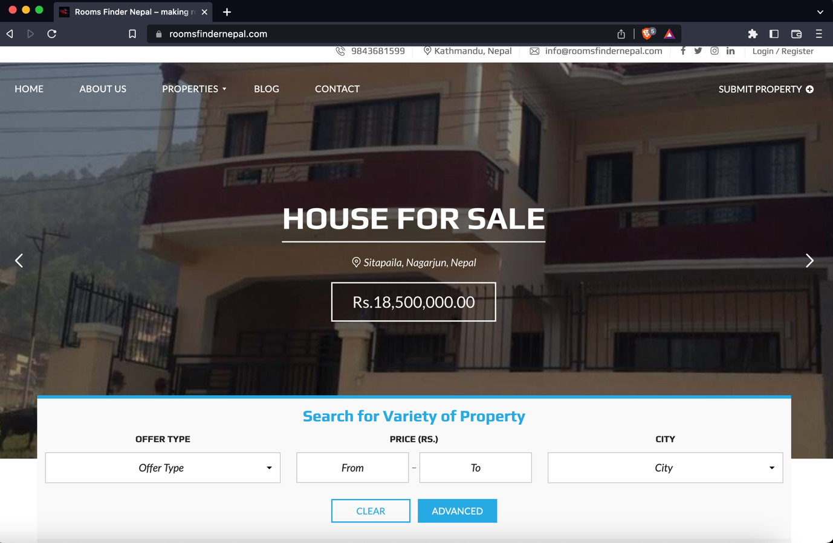

Figure 1: (Room Finder Nepal, 2022) Room Finder Nepal

### Gharbeti

Gharbeti is a web platform that provides a comprehensive list of available rental properties in Nepal, including buildings, apartments, rooms, hostels, and land. Users can search and book these properties online, and the list is regularly updated with detailed information. It offers an efficient way for people to find and book the perfect rental property. (Gharbeti, 2022).

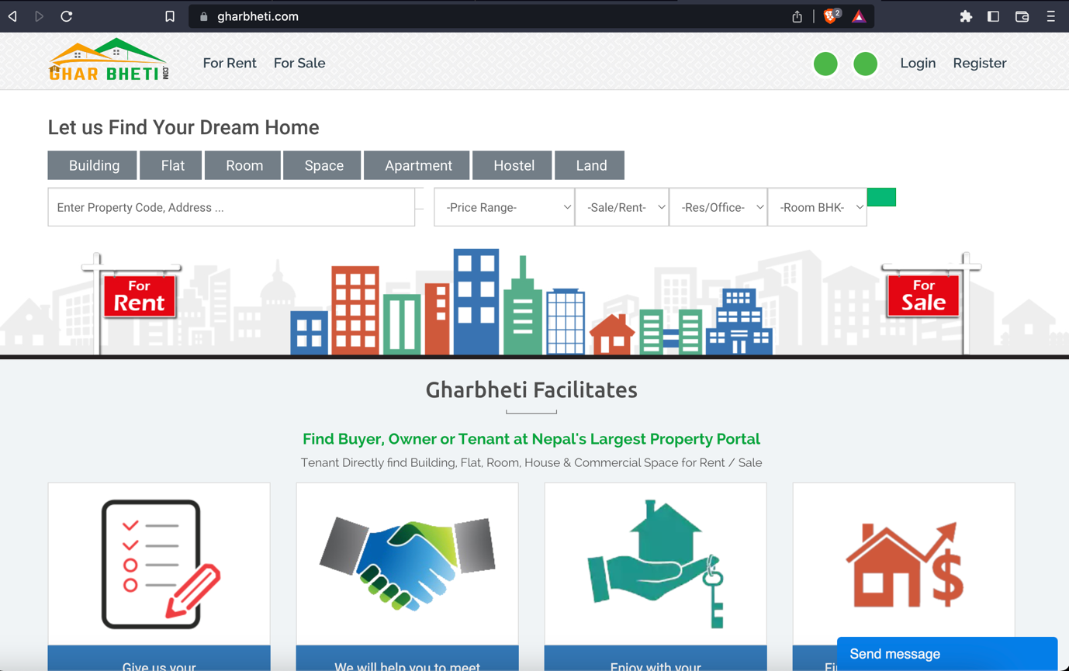

Figure 2: (Gharbeti, 2022) Gharbeti

### DalayDai

DalayDai.com is a free online platform for buying and selling Houses, Lands and everything Real Estate. dalaydai.com makes, searching a perfect Home or a perfect plot of Land for Nepali people effortless and easy like it has never been. With frequent updates to the platform (Dalay Dai, 2022).

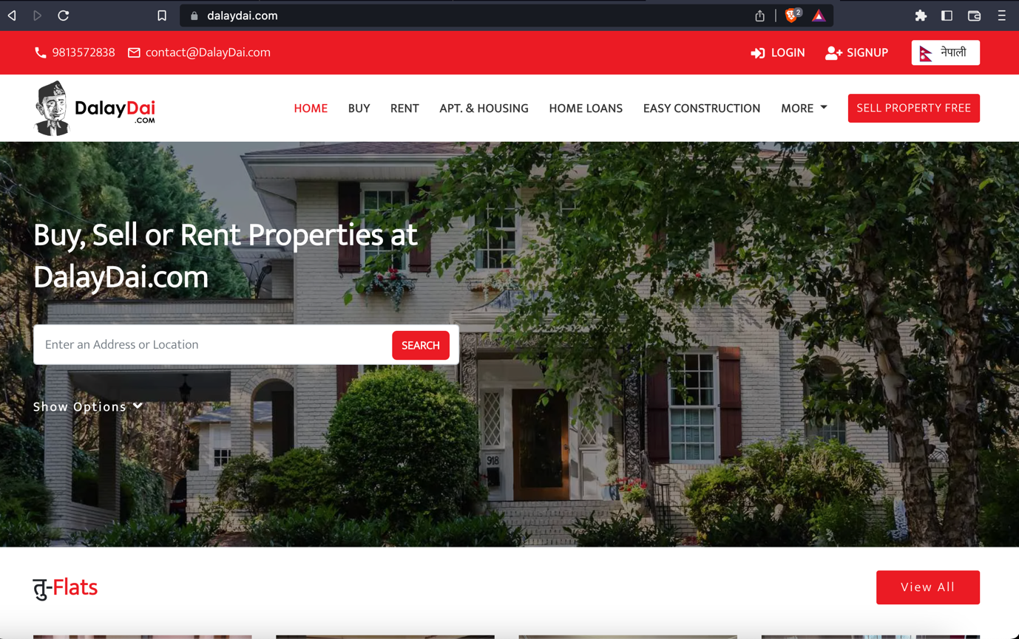

Figure 3: (Dalay Dai, 2022) Dalay Dai

### Hamro rental

Hamro Rental is a free online platform for buying and selling Houses, Lands, Apartments Shops. However, this site seems to be inactive of long time and the user experience while using this site is also not that great. (Hamro Rental, 2022)

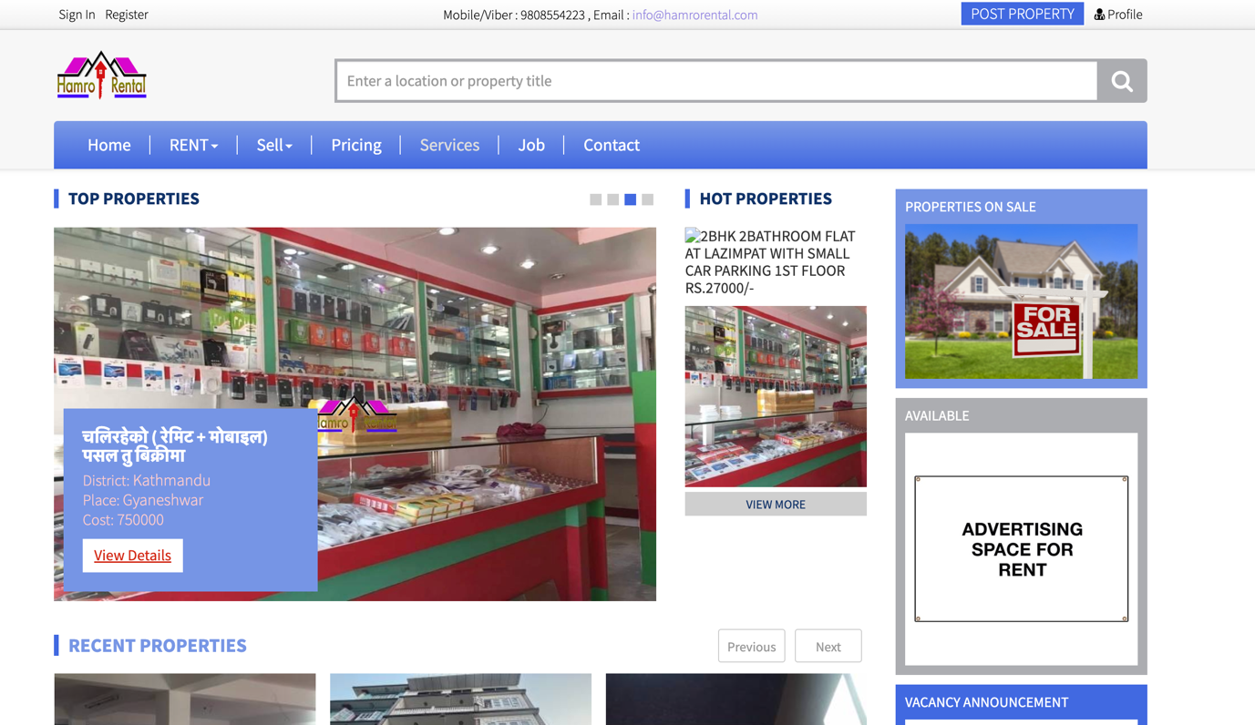

Figure 4: (Hamro Rental, 2022) Hamro Rental

## **Comparison Between the Systems**

|  |  |  |  |  |  |  |
| --- | --- | --- | --- | --- | --- | --- |
| **S.N.** | **Features** | **Similar Projects** | | | | |
| **Room Finder Nepal** | **Gharbeti** | **DalayDai** | **Hamro Rental** | **MYRoom (My Project)** |
| **1** | Advance Search Feature | **Checkmark** | **Checkmark** | **Checkmark** | **Checkmark** | **Checkmark** |
| **2** | Wishlist | **No sign** | **No sign** | **Checkmark** | **Checkmark** | **Checkmark** |
| **3** | Location | **Checkmark** | **Checkmark** | **No sign** | **No sign** | **Checkmark** |
| **4** | Ad Expiry Time | **No sign** | **Checkmark** | **Checkmark** | **No sign** | **Checkmark** |
| **5** | Comments in ads | **Checkmark** | **No sign** | **Checkmark** | **Checkmark** | **Checkmark** |
| **6** | Realtime Chat | **No sign** | **No sign** | **No sign** | **No sign** | **Checkmark** |
| **7** | Report unreliable ads | **No sign** | **No sign** | **No sign** | **No sign** | **Checkmark** |
| **8** | Pet Allowed Filter | **No sign** | **No sign** | **No sign** | **No sign** | **Checkmark** |
| **9** | Show Nearby Schools, Markets, Hospitals in map view for property | **No sign** | **No sign** | **No sign** | **No sign** | **Checkmark** |
| **10** | Upload Video tour for the property | **No sign** | **No sign** | **No sign** | **No sign** | **Checkmark** |

Table 1: Comparison Between Similar systems